The Pennsylvania State University

The J. Jeffrey and Ann Marie Fox Graduate School

enter your title here (heading 1)

A Dissertation in

Enter your Graduate Major

by

Enter your Name

© 2026 Enter your Name [Optional]

Submitted in Partial Fulfillment
of the Requirements
for the Degree of

Choose your Degree

Choose your Graduation Date

The dissertation of (enter your name) was reviewed and approved by the following:

Professor’s Name
(Do not use designations such as “Ph.D” or “Dr.” for committee names)
Title(s)
Dissertation Advisor
Chair of Committee

Professor’s Name
Title

Professor’s Name
Title

Professor’s Name
Title

Professor’s Name
Title(s)
Head of the Department or Director of Graduate Studies

ABSTRACT

Enter text here.

TABLE OF CONTENTS

LIST OF FIGURES v
LIST OF TABLES vi
ACKNOWLEDGEMENTS vii
Chapter 1 Replace with Title (Heading 2) 1
1.1 Replace with subheading (Heading 3) 1
1.1.1 Replace with subheading (Heading 4) 1
1.1.1.1 Replace with subheading (Heading 5) 1
1.2 Page Breaks and Section Breaks (Heading 3) 1
Chapter 2 Replace with Title (Heading 2) 2
2.1 Figure Example (Heading 3) 2
2.2 Table Example (Heading 3) 3
Chapter 3 Replace with Title (Heading 2) 4
Chapter 4 Replace with Title (Heading 2) 5
Chapter 5 Replace with Title (Heading 2) 6
Chapter 6 Replace with Title (Heading 2) 7
Appendix A Appendix Title 8
References 9

LIST OF FIGURES

Figure 1.1: Show/Hide ¶ 1
Figure 2.1: The Nittany Lion 2

LIST OF TABLES

Table 2.1: Front Matter Requirements 3

ACKNOWLEDGEMENTS

If you have received federal funding, please include an acknowledgment in this section. Be sure to list all relevant award numbers and include the following disclaimer:
“Any opinions, findings, and conclusions or recommendations expressed in this publication are those of the author(s) and do not necessarily reflect the views of the [name(s) of awarding agency(ies)].”

Chapter 1
Replace with Title (Heading 2)

Please remove this instructional text and replace it with your work.
This text uses the “Normal” style. Please use “Normal” for the body of your work. Text styles are located in the style gallery above (in the menu under Home).
Text in the body of your work may be single, double, or one-and-a-half spaced.
All Chapter Headings should use “Heading 2” style. Subheadings should begin with “Heading 3” style and go in numerical order.

1.1 Replace with subheading (Heading 3)

1.1.1 Replace with subheading (Heading 4)

1.1.1.1 Replace with subheading (Heading 5)

1.2 Page Breaks and Section Breaks (Heading 3)
When you replace the sample text, figures and tables with your own work, please make sure you do not delete the page breaks. Page breaks and section breaks allow the chapter formatting and pagination to remain in place. You can view the page and section breaks in this template by clicking the Show/Hide ¶ button on the Home menu (Fig. 1.1).

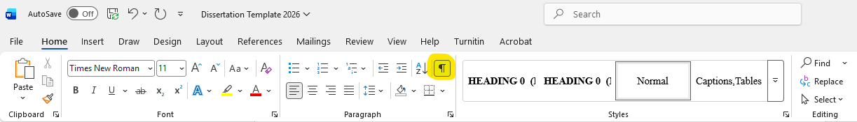
Figure 1.1: Show/Hide ¶ (Caption, Figures)

Chapter 2
Replace with Title (Heading 2)

Please remove all sample text, including figures and tables, and replace with your work. Below are some examples of figures and tables.

2.1 Figure Example (Heading 3)
All figures and tables in your work must be properly referenced in the text. For example, below you will find a picture of the Nittany Lion (Fig. 2.1). All figure captions should go directly beneath the figure and use the style: Captions, Figures.

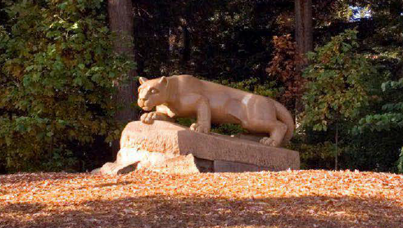
Figure 2.1: The Nittany Lion (Caption, Figures)

2.2 Table Example (Heading 3)
All table captions should go directly above the table and use the style: Captions, Tables. Please see the example (Table 2.1) below:

Table 2.1: Front Matter Requirements (Captions, Tables)

Page |  | Required |  | Visible Page Number
Title Page |  | Mandatory |  | No
Committee Page |  | Mandatory |  | Yes
Abstract |  | Mandatory |  | Yes
Table of Contents |  | Mandatory |  | Yes
List of Figures |  | Mandatory (if figures used) |  | Yes
List of Tables |  | Mandatory (if tables used) |  | Yes
Acknowledgments |  | Mandatory (if federal funding used) |  | Yes
Frontispiece |  | Optional |  | Yes
List of Symbols/List of Abbreviations |  | Optional |  | Yes
Dedication |  | Optional |  | Yes

Chapter 3
Replace with Title (Heading 2)

Enter text here.

Chapter 4
Replace with Title (Heading 2)

Enter text here.

Chapter 5
Replace with Title (Heading 2)

Enter text here.

Chapter 6
Replace with Title (Heading 2)

Enter text here.

Appendix A
Appendix Title

Unless you include an ‘Appendix B’ in your work, please remove ‘A’ from your Appendix title.

References

Enter text here.

VITA

Your Name

The vita is a doctoral requirement and should be the last page of your work. It must meet the following criteria:
- One page maximum
- DO NOT include a page number
- DO NOT list the vita in the table of contents
- DO NOT include personal information (such as home address or phone number)

